DAD – Tasks – < specify task > ( e.g. Access Lesson 3 )

Student ID: 103577332

Student Name: Ibrahim Oztas

## Task 1.

## Task 2

Paste your screen captures for this task here.

## Task 3

Paste your screen captures for this task here.

## Task 4

Paste your screen captures for this task here.

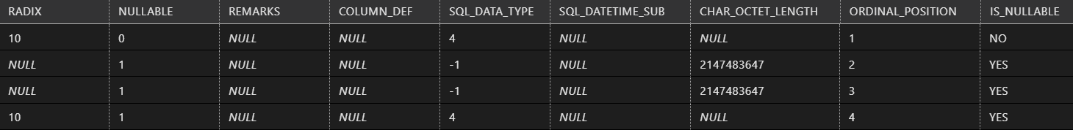

## Task 5

Paste your screen captures for this task here.

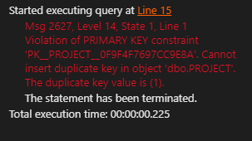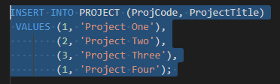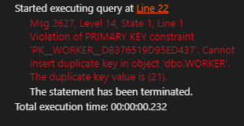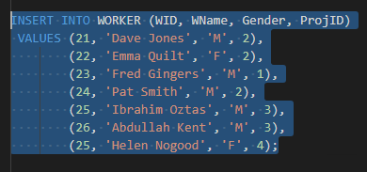

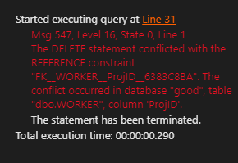

## Task 6

Paste your screen captures for this task here.

## Task 7

Paste your screen captures for this task here.

## Task 8

Paste your screen captures for this task here.

## Task 9

Paste your screen captures for this task here.

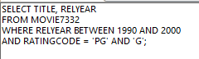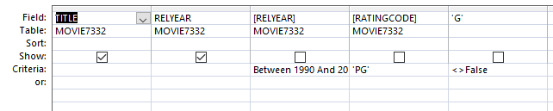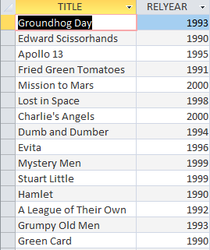

## Task 10

Paste your screen captures for this task here.

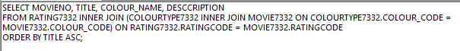

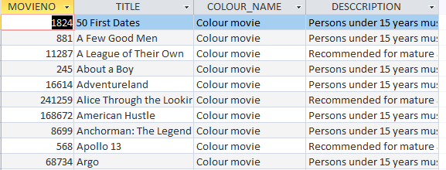

## Task 11

Paste your screen captures for this task here.

## Task 12

Paste your screen captures for this task here.

## Task 13

Paste your screen captures for this task here.

## Task 14

Paste your screen captures for this task here.

## Task 15

Paste your screen captures for this task here.

## Task 16

Paste your screen captures for this task here.

